Version Control
Date - 16 September 2026 Full Name - Satvik Singh

What is version control?
Version control, also known as source control, is the practice of tracking and managing changes to software code. Many tools exist to aid in this process. These tools store every version of the program and retain logs about what was deleted and added, as well as where and when.
Why is version control important?
Have you ever:
- Made a change to code, realised it was a mistake and wanted to revert back?
- Lost code or had a backup that was too old?
- Had to maintain multiple versions of a product?
- Wanted to see the difference between two (or more) versions of your code?
- Wanted to prove that a particular change broke or fixed a piece of code?
- Wanted to review the history of some code?
- Wanted to submit a change to someone else's code?
- Wanted to share your code, or let other people work on your code?
- Wanted to see how much work is being done, and where, when and by whom?
- Wanted to experiment with a new feature without interfering with working code?
In these cases, and no doubt others, a version control system should make your life easier.

Mentioned below are the benefits of version control systems:

The Utility of Having History

Gives development a direction: A VCS keeps a complete long-term change history of every file.
Having this history allows developers to look into previous versions to understand how the current solution to a certain problem came about. The comment trail may help prevent developers from going in a direction that the team has already explored fruitlessly, or help them realize that the low-hanging fruit might be a trap and understand why the current codebase is the way it is.

Troubleshooting: Having a history helps identify the root causes of bugs by comparing changes and pinpointing issues that may have been introduced after a specific version.

Stability: VCS enables the possibility to “undo” or rollback the program to a last known working state. If a bug is discovered in a live application, the code can be quickly reverted to a known stable version.

Preventing Merge Conflicts
During the development of a program, it is likely that multiple team members will need to make concurrent changes to the same source code file at the same time. A VCS tracks and helps resolve these conflicts, leaving an audit trail that provides insight into the project's history. Solo developers also benefit from using branches to work on separate features independently.
Backup and Safety
Once a VCS has begun tracking a source code file system, it keeps a history of changes and the state of the source code throughout a project’s history.
Without these benefits, working on any large codebase would become more cumbersome as the number of contributors and the size of the source code increase over time. Everyone would step on each other's toes, and management and further progress would consume massive amounts of time and require a lot of coordination.
Since manual backups and merges are quite painful, a VCS heavily optimizes the backup workflow, providing the mental bandwidth for developers to focus on development instead of managing software and backups.

What are the different types of version control?

Lock-based
A lock-based version control system uses file locking to manage concurrent access to files and resources. File locking prevents two or more users from making conflicting changes to the same file or resource.

Optimistic
In an optimistic version control system, every user has their own private workspace. When they want to share their changes with the rest of the team, they submit a request to the server. The server then looks at all the changes and determines which ones can be safely merged together.

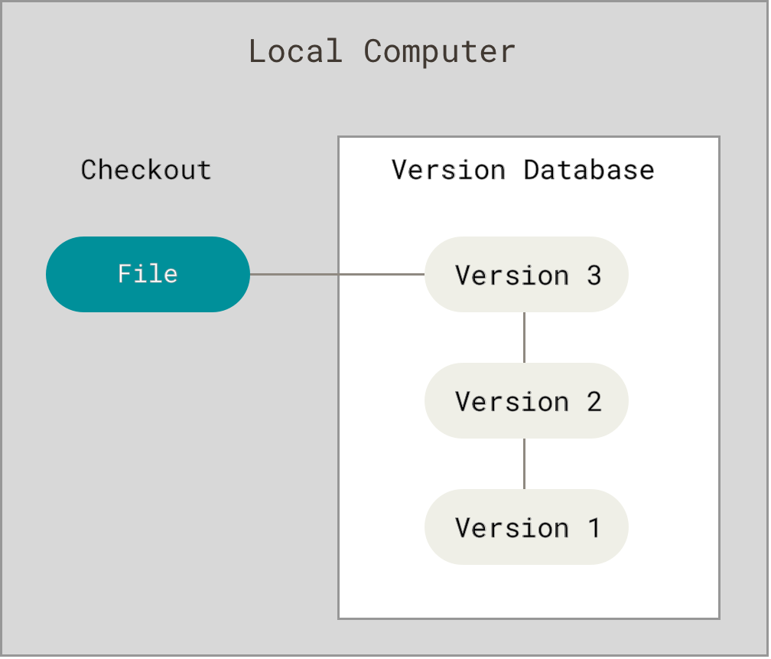
Local Version Control Systems
A common way people create backups is to rename the files periodically (for example file1,file2,file_final,file_final_final) and store them in a hard disk, it is common due to its simplicity but it is also incredibly error prone. It is easy to forget which directory you’re in and accidentally write to the wrong file or copy over files you don’t mean to.
To deal with this issue, programmers long ago developed local VCSs that had a simple database that kept all the changes to files under revision control.
Figure 1. Local version control

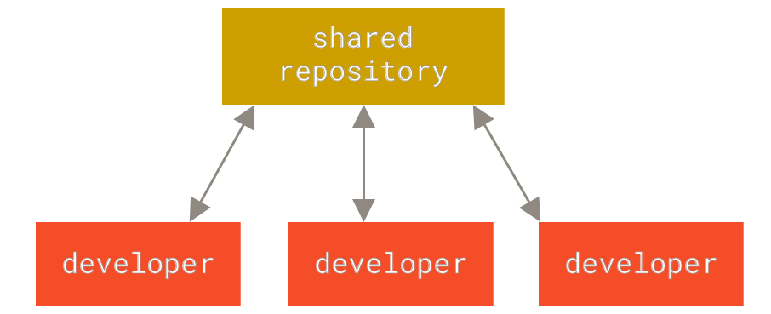
Centralized Version Control Systems
Figure 2. Centralized version control
The next major issue that people encounter is that they need to collaborate with developers on other systems. To deal with this problem, Centralized Version Control Systems (CVCSs) were developed. These systems (such as CVS, Subversion, and Perforce) have a single server that contains all the versioned files, and a number of clients that check out files from that central place.
However, this setup has downsides. A central server is a single point of failure; if it goes down or breaks without proper backups, the entire project history can be lost. Local VCSs face the same single-point-of-failure issue.

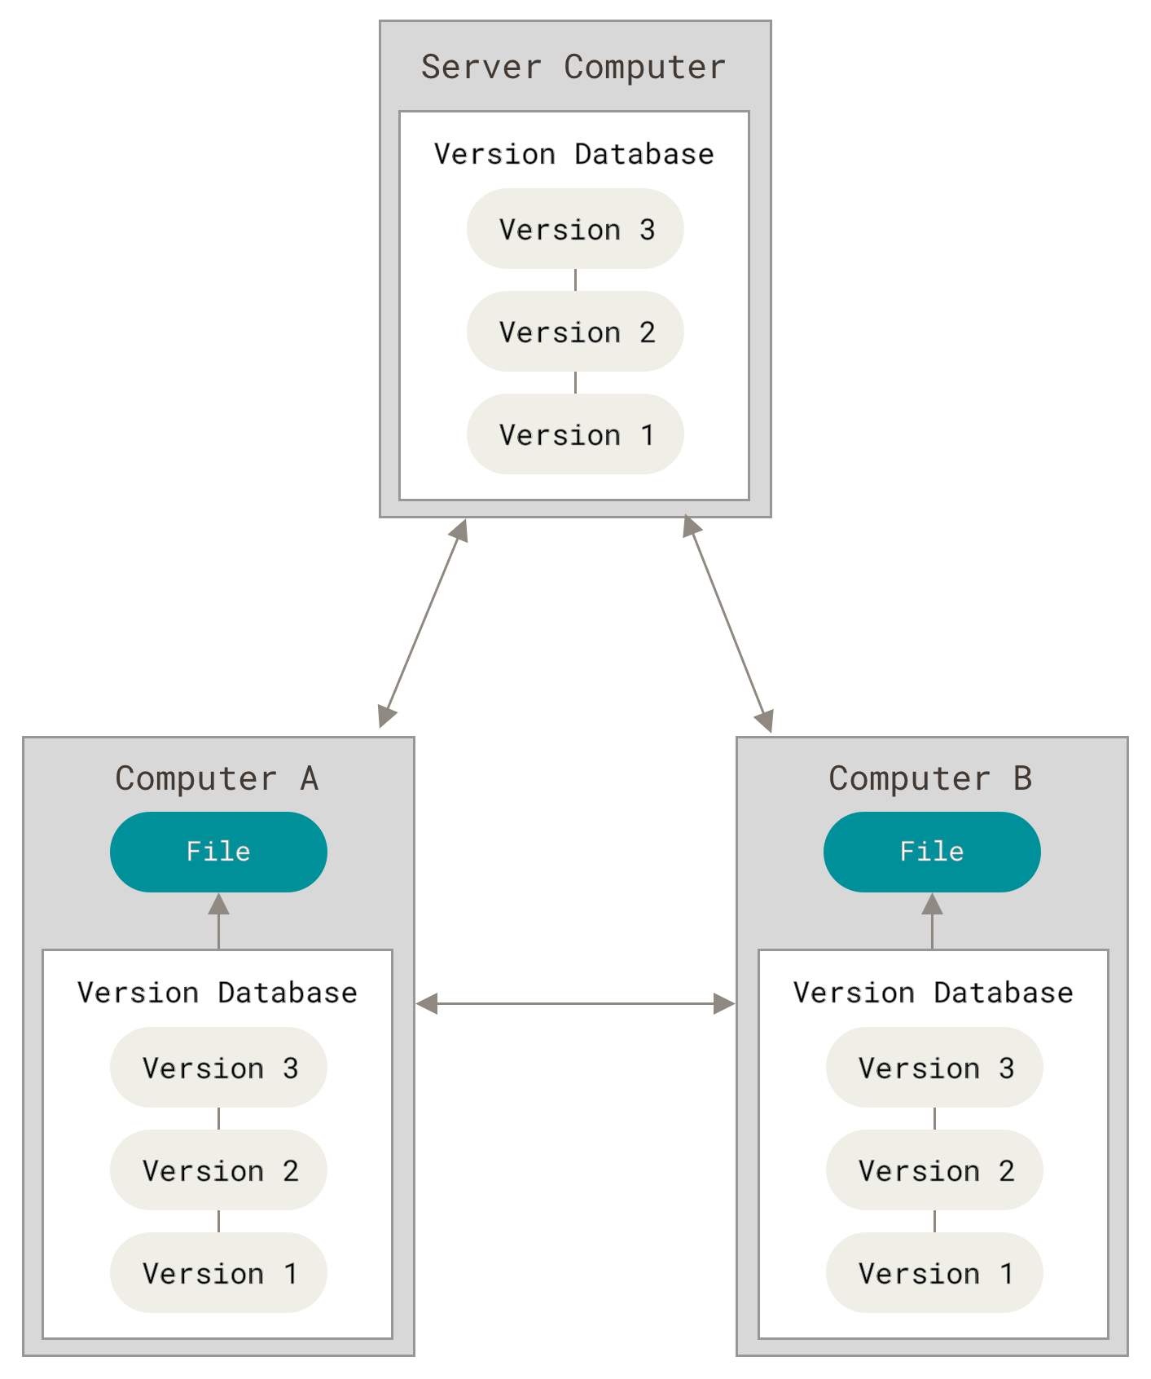
Distributed Version Control Systems
This is where Distributed Version Control Systems (DVCSs) step in. In a DVCS, clients don’t just check out the latest snapshot of the files instead, they fully mirror the repository, including its full history. Thus, if any server dies, and these systems were collaborating via that server, any of the client repositories can be copied back up to the server to restore it. Every clone is really a full backup of all the data.
Figure 3. Distributed version control

Important Git Commands

1. git status

git status
It tells you what’s changed, what’s staged, what’s untracked, and what branch you’re on.

2. git add

git add <file>
git add .
git add -p
Stages changes for the next commit. You can stage individual files, everything in the current directory, or—with the -p (patch) flag—interactively choose specific hunks of changes within the file.

3. git commit

git commit -m "Fix null pointer in payment validation"
Records the staged snapshot. Write commit messages that explain why, not what—the diff already shows what changed.

4. git push

git push
git push --set-upstream origin feature/login-redesign
Sends your local commits to the remote repository. If the branch doesn’t exist remotely yet, you’ll need –set-upstream (or -u for short) to create the tracking relationship.

5. git pull

git pull
git pull --rebase
Fetches remote changes and merges them into your current branch. The –rebase variant replays your local commits on top of the fetched changes instead of creating a merge commit, keeping the history linear.

6. git fetch

git fetch
git fetch --all
Downloads changes from the remote without merging anything. It’s the non-destructive sibling of git pull.

7. git diff

git diff
git diff --staged
git diff main..feature/new-api
Shows the actual line-by-line differences. Without arguments, it shows unstaged changes. With –staged, it shows what’s about to be committed. With two branch names, it compares them.

8. git log

git log
git log --oneline
git log --oneline --graph --all
Shows commit history. The default output is verbose; –oneline compresses each commit to a single line. Add –graph –all and you get an ASCII-art visualization of your branch topology, useful when you’re trying to understand how a feature branch diverged.

9. git branch

git branch
git branch feature/checkout-flow
git branch -d old-experiment
git branch -m old-name new-name
Lists, creates, deletes, or renames branches. The -d flag is a safe delete (it won’t let you delete an unmerged branch). Use -D to force it, but you’re throwing away work this way.

10. git checkout / git switch

git checkout feature/api-v2
git switch feature/api-v2
git switch -c feature/new-thing
Switches branches. git switch was introduced because git checkout was overloaded—it also restores files, which confused people.

11. git merge

git merge feature/user-auth
Combines the history of one branch with another. If Git can do it cleanly (no conflicting changes), it’s seamless. If not, you’ll need to resolve conflicts manually.

12. git clone

git clone https://github.com/your-org/your-repo.git
git clone <url> -b <branch>
Downloads an entire repository and its history to your local machine. You generally do this once per project.

Setting Up and Configuring Git
These commands set the stage. You use them when you’re starting a new project, joining a team, or customizing how Git behaves on your machine.

13. git init

git init
git init my-new-project
Creates a new Git repository. It generates the .git directory and all its internal structure. You’ll use this when starting a project from scratch.

14. git config

git config --global user.name "Your Name"
git config --global user.email "you@example.com"
git config --global core.editor "code --wait"
git config --list
Sets configuration values at the system, global (user), or repository level. At a minimum, set your name and email as they’re attached to every commit you make.

15. git help

git help commit
git help -a
Opens the manual page for any Git command. The -a flag lists every available command.

16. git version

git version
Prints the installed Git version. Useful when debugging behavior differences between machines.

Branching, merging, and navigating history
Branching is Git’s "killer feature." It’s cheap (a branch is just a 41-byte file containing a commit hash), fast, and enables the kind of parallel development workflows that would have been impractical with older version control systems.

17. git rm

git rm obsolete-file.txt
git rm --cached sensitive-config.yaml
Removes a file from both the working directory and the staging area. The –cached flag removes it from tracking without deleting it from disk. Useful when you’ve accidentally committed a file that should be in .gitignore.

18. git mv

git mv old-name.js new-name.js
Renames or moves a file and stages the change in one step.

19. git restore

git restore modified-file.js
git restore --staged accidentally-added.js
git restore discards working directory changes; git restore –staged unstages a file without touching the working directory.

Inspecting History and Debugging
When something breaks, these commands help you figure out what happened, when it happened, and who’s responsible.

20. git show

git show abc1234
git show HEAD~3
Displays the details of a specific commit (i.e., the author, timestamp, message, and the actual diff).

21. git blame

git blame src/utils/validate.js
Annotates each line of a file with the commit and author who last modified it.

22. git revert

git revert abc1234
Creates a new commit that undoes the changes from a previous commit. This is the safe way to undo something that’s already been pushed.

23. git clean

git clean -n
git clean -fd
Removes untracked files from the working directory. The -n flag does a dry run (shows what would be deleted). The -f flag is required to actually delete anything—Git forces you to be explicit about destruction. The -d flag includes untracked directories.

References
1. Atlassian. What is Version Control?
2. Bitbucket. Version Control Software
3. GeeksforGeeks. Version Control Systems
4. GitLab. What is Version Control?
5. Git Documentation. Getting Started - About Version Control
6. Stack Overflow. Why should I use version control?
7. Tricentis. 10 Common Git Commands Everyone Should Know

